

**PROJECT REPORT:-**

**Hostel Mess Management System**

**( B.Tech-Cse)**

(Submitted in partial fulfillment of the requirement for 4th semester)

**PRIYANSHI KAMBOJ**

**2016928**

**4th SEMESTER**

**ACKNOWLEDGEMENT:**

Here by I, ‘PRIYANSHI KAMBOJ’ , am submitting the project report on **“Hostel Mess Management System”** as per the scheme of Graphic Era Deemed University, Dehradun.

I would also like to express my gratitude to my mentor Ms. Meenakshi Mandola mam and all the faculty members of the computer science department for their constant encouragements and much needed support for the successful completion of the project.

Finally I am very much thankful to all , friends and my parents for their constant encouragement, support and help throughout the period of project conduction.

**Date-14/07/2022**

**PRIYANSHI KAMBOJ**

**2016928**



**CERTIFICATE**

This is to certify that the project report entitled “Hostel Mess Management System” is a bonfire project work carried out by Priyanshi Kamboj, roll no- 2016928, in partial fulfillment of the award of the degree of B-Tech of Graphic Era Deemed University, Dehradun during the academic year 2021-2022. It is certified that all corrections/suggestions indicated for internal assessment have been incorporated. The project has been approved as it satisfies the academic requirements associated with the degree mentioned.

**Dr. Devesh Pratap Singh,**

**HOD (Computer Science)**

**MOTIVATION FOR DOING THE PROJECT-**

Education In today’s world, administration & management of organizations, has become a tedious and complex task. It requires careful planning, systematic approach and accurate control of administrative processes to avoid making any mistake and any kind of confusion. Coupled with tight competition from the industry, every institution is increasingly seeking the help of information technology to improvise their facilities and maintain a competitive edge.

This type of management systems software are helpful in managing Student, Teacher, Courses, Batches, Fees, Attendance, and Marks. Provides easy reports like Outstanding fees, Marks, Attendance etc. These type of software are a ‘MUST HAVE’ software for colleges to store and retrieve their data without any mistake.

The software guarantees saving of money and time for owners apart from organizing the institute information.

**ABOUT THE PROJECT:-**

I have made a project on Hostel Mess Management System where each student has their own username and password where everything is visible to them on a single window( i.e. Their daily attendance, the amount left, every day’s menu, their attendance).

Each student can maintain an account here and manage it accordingly to get the information about their preference and the monthly mess changes as well.

This system will reduce the strenuous work of the mess workers and will also be fair system where a student will pay for whatever they will consume. This software will reduce the tire-some and time consuming work of maintaining handwritten lists.

**Tools And Software Used:-**

* In order to accomplish this project the tools used are:-

1. Visual Studio Code
2. HTML , CSS , JAVA SCRIPT (front end)
3. Node JS , Express , Template Engine (back end )
4. Mongo DB , Mongoose (database)
5. NPM package Manager

* Visual Studio Code was used for writing code .It is a very handy Code editor .
* I have designed all my pages in HTML and for designing I have used CSS and little pinch of Java script.
* For creating custom backend I have used NodeJS , Express framework is used to create web app , for making my web app dynamic I have used PUG template engine .
* MongoDB database is used to store data entered by the user in the registration form and the contact form in my web application.
* Mongoose is used to manage all the CRUD operation applied on my project by making bridge between NodeJS and mongoDB .

**INTRODUCTION:-**

Building up a project on Web Development was a great piece of experience, it not only help me in gathering information about new technologies but also made me realize the use of programming in real life.

Initially I started with learning basis web designs using HTML , CSS and JAVASCRIPT , later I learned different backend tools like NODEJS , EXPRESS etc.

This was all that a user can see on the front but there is a lot that is written in the back that the server processes .

The backend is used to serve the content or web page as per the request of the user .

We can define the behaviour of our web application using the backend.

**PRODUCT FUNCTIONS:-**

* Separate login options for everyone and the Id’s assigned will be unique.
* The attendance will be recorded for each day and there will be an option to mark one’s attendance.
* A list of all the grocery items available.
* A list of details of the quantity and their status of availability.
* A list of food from which student can choose their preference.
* A list of food from which student is allergic to (if any).
* Information about the preference, monthly mess charge, monthly changes in the mess.
* It can also record mess fines.
* Also there will be a complaint portal for all the students.

**METHODOLOGY:-**

* Front page of the project is a web page that contains all the necessary details of the coaching institute and a registration form for the students who want an online registration and want to use our services.
* There are different modes of login i.e. for the student and the faculty that directs to the desired page.
* A student once registered can access all the study material available on the website .

**ARCHITECTURE OF MONGODB:-**

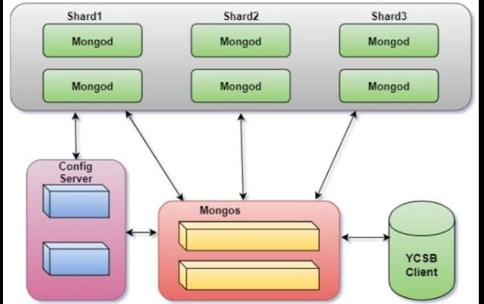

**ARCHITECTURE OF NODEJS:-**

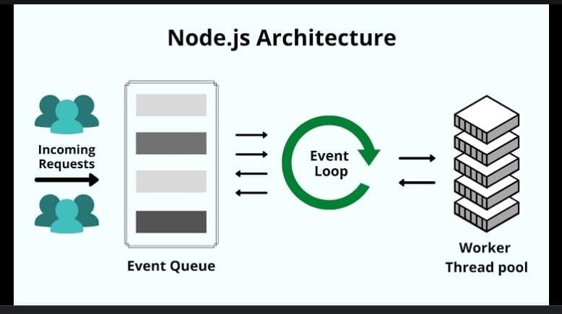

**OPERATING ENVIRONMENT:-**

The collective use of the mentioned tools is used to handle all the functionality , like:-

A login page in our project validates the login field from the data stored in our local data base and if the credentials are matched to the database then only we can get access to the desired page.

Similarly a contact page is built that stores all the contact queries to our database from where they can be monitored and a response can be generated from the coaching management end .

Later in our web app we have some static pages that stores different study materials for the students that have registered from the web site and also that have got offline registration .

Lastly CMS is a very interactive and powerful tool in field of education.

**CONCLUSION :-**

The delivered system “HOSTEL MESS MANAGEMENT SYSTEM” software has been designed to achieve maximum efficiency and reduce the time taken to handle the handwritten lists. Furthermore, it is designed to replace an existing manual record system thereby reducing time taken for calculations and for storing data.

The system is strong enough to withstand regressive daily operations under conditions where the data is cleaned over a certain time of span. The implementation of the system in the organization will considerably reduce data entry, time and also provide readily calculated reports. The System has adequate scope for modification in future if it is necessary.

The project helped me know about the various tools and technologies that are available in the field of development and the project was not just theoretical but a real life based that we can easily connect to.

Overall working on this project was great fun as I came up with great piece of knowledge and understanding of the topic and I am excited to work further on such other projects in upcoming semesters.